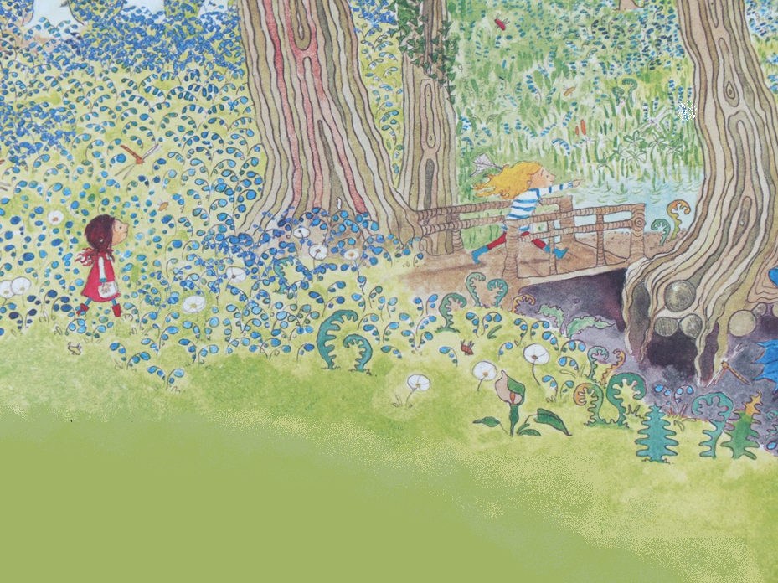
the crowds on Palm Sunday
Maths:
- Money
- Know and recognise the value of coins and notes
- Mass and Capacity
- Comparing mass using heavier/lighter than
- Ordering objects by mass
- Measure mass by using standard and non-standard units
- Compare and order capacity of containers
- Measure capacity using standard and non-standard units

Music:
- To use voices and bodies expressively to explore tempo.
- Demonstrate slow and fast with our bodies
- Perform with an instrument
- Sing in time with memory and accuracy
- Keep a steady pulse
- Perform a song using a singing voice
RE: Judaism
Does visiting the synagogue help Jewish children feel closer to God?
ICT skills in Computing:
- E-safety
- Programming
Design Technology
Mechanisms: Wheels and Axles
      - Explain that wheels move because they are attached to an axle.
- Recognise that wheels and axles are used in everyday life, not just in cars.
- Identify and explain vehicle design flaws using the correct vocabulary.
- Design a vehicle that includes functioning wheels, axles and axle holders.
- Make a moving vehicle with working wheels and axles.
- Explain what must be changed if there are any operational issues.

Curriculum Web
Woodlands
Year 1 - Term 6
Hook for Learning:
Watch a meteor shower!

Science: Plants
- Identify and name a variety of common wild and garden plants, including deciduous and evergreen trees.
- Identify and describe the basic structure of a variety of common flowering plants, including trees.
- Understand the look and structure of a variety of wild and garden plants, including trees
Geography:
- Recognise and name man-made (human) and natural (physical) geography features.
- Name the key natural (physical) and man-made (human) features of Tidworth.
- Make a simple map of the area around school (walk local area).
- Understand that nearly everywhere has both human and physical features and these can be shown on maps.

-

PE:
- Dance
- Sports Day

PSHE: Changing Me
- Starting to understand the life cycles of animals and humans
- Comparing ourselves now to when we were babies
- Identifying parts of the body that make boys and girls different, using the correct names
- Understanding that when we learn something new we change a little bit
- Learning how to cope with changes

English: Our text for the term will be ‘Look Up’ and ‘Dragons Post’.
- Daily phonics sessions
- Role play and active learning
- Grammar rules taught explicitly
- Writing the ending of a story.
- Write a letter.
Value of the term:
happiness

