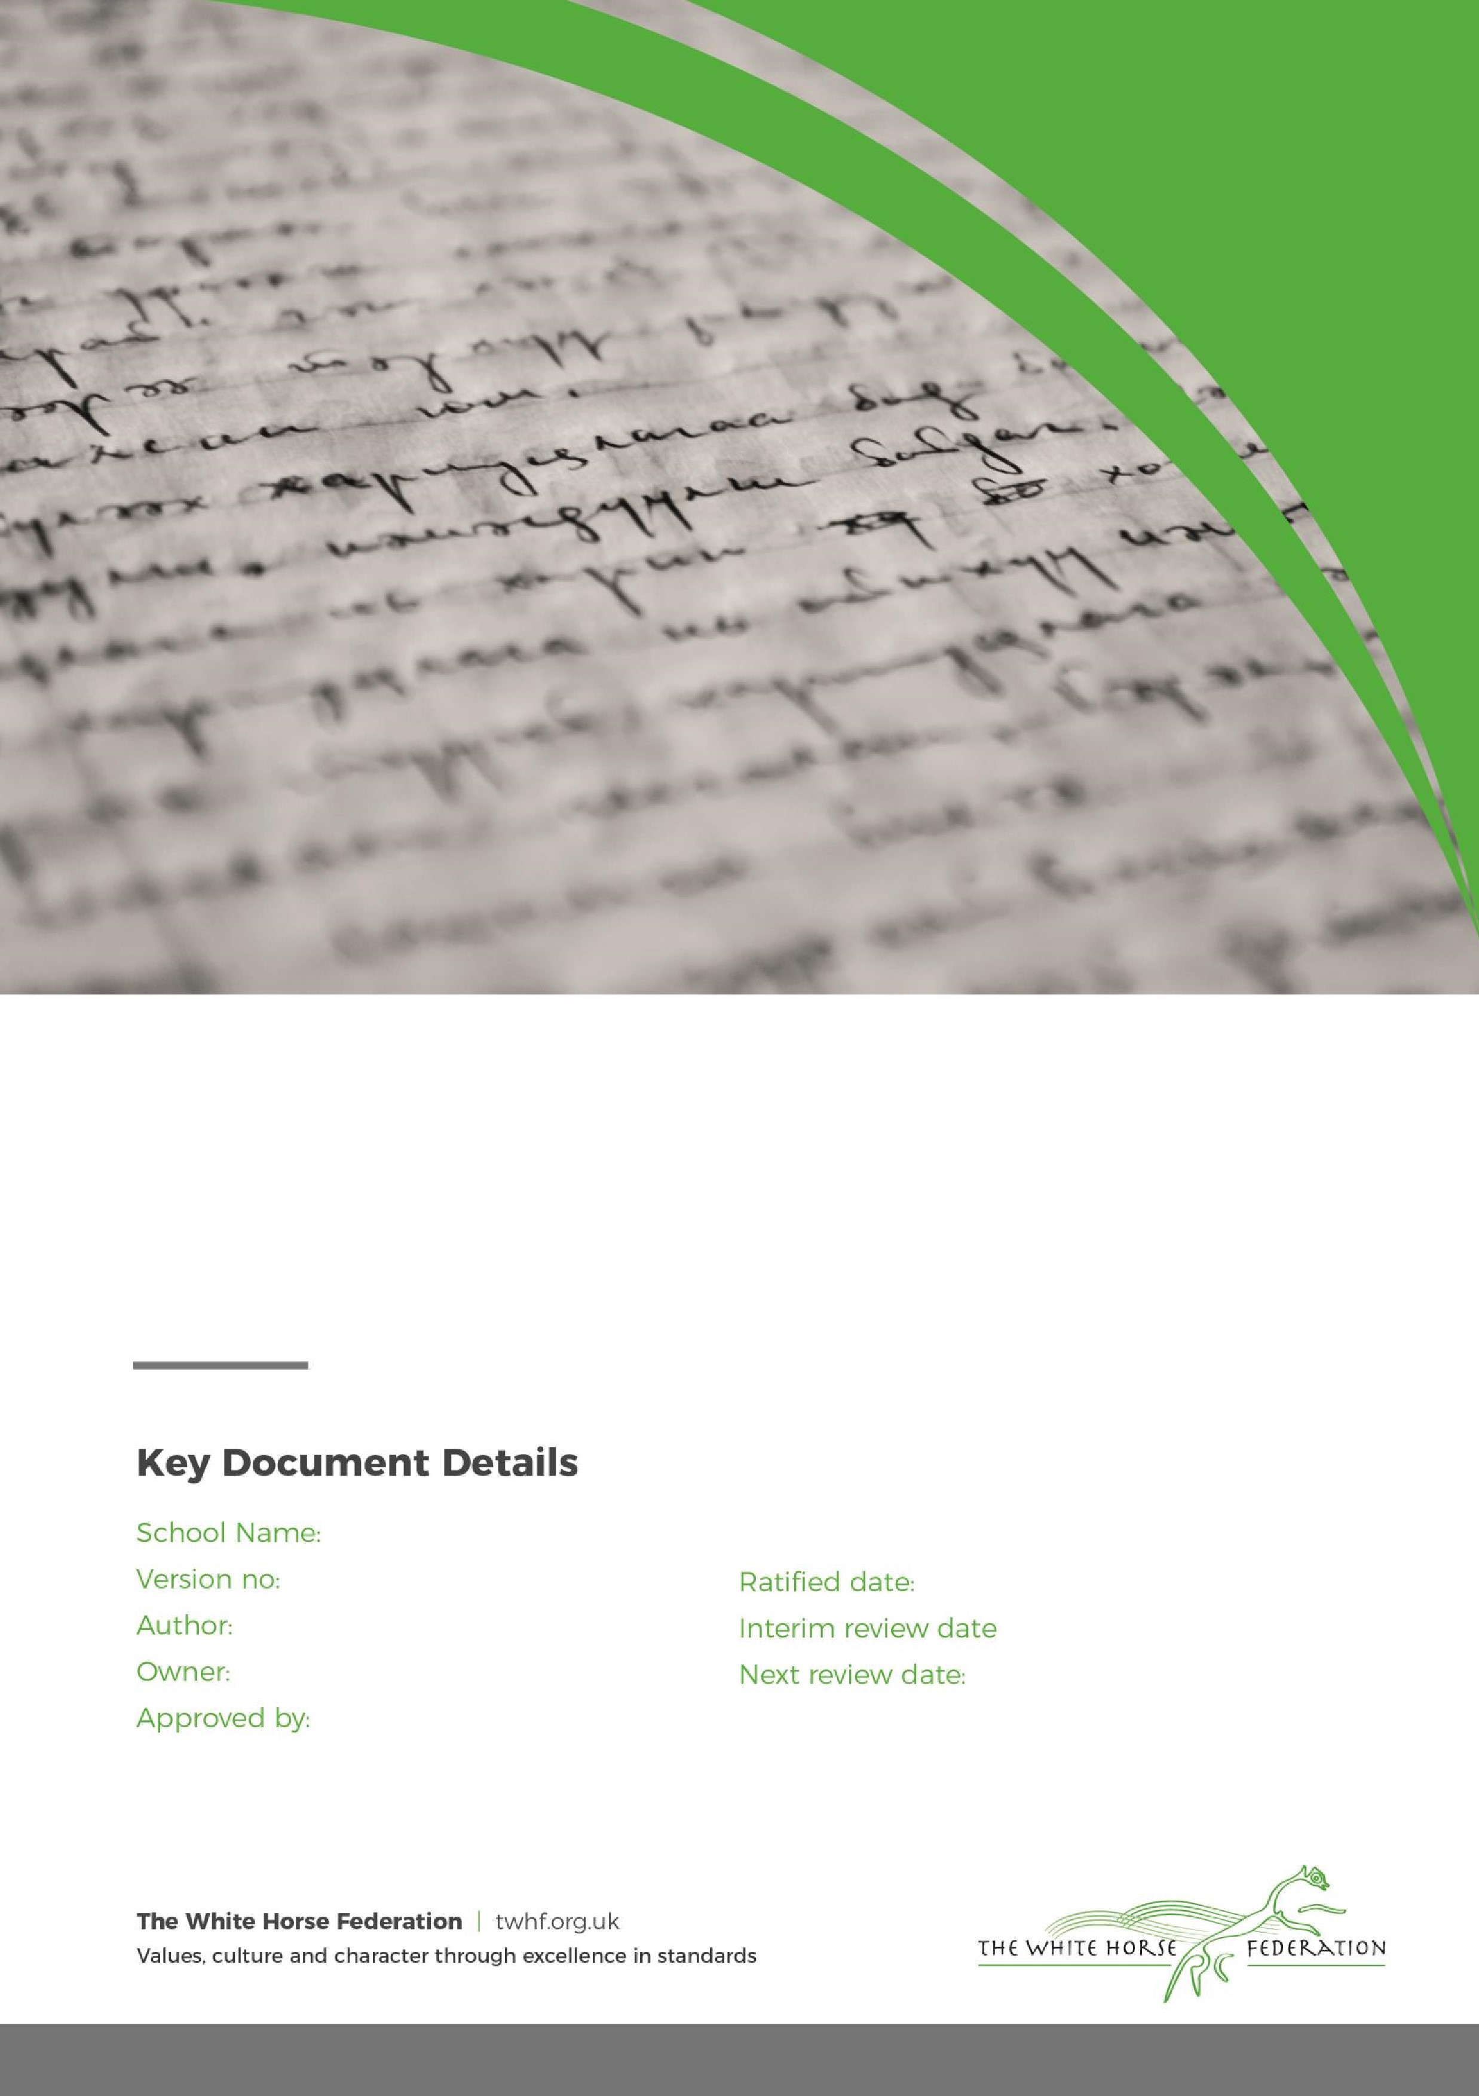

Early Years Policy

1

Lisa Davies

Director of Education

July 2025

July 2027

Zouch Academy

Director of Education

July 2026

Changes 2

Section 1 – Aims 2

Section 2 – Legislation 3

Section 3 – Structure of the EYFS 3

Section 4 – Curriculum 3

4.1 EYFS Framework 3

4.2 TWHF ENRich Curriculum 3

4.3 Planning 4

4.4 Teaching 5

Section 5 – Assessment 5

Section 6 – Working with parents and carers 6

Section 7 – Safeguarding and welfare procedures 6

7.1 Oral health and tooth brushing 7

Section 8 – Monitoring arrangements 7

Appendix 1. List of statutory policies and procedures for the EYFS 8

|  |  |  |  |  |
| --- | --- | --- | --- | --- |
| Version | Date | Page document | Change | Origin of change e.g. Change in legislation, Policy review. |
| 1.0 | July 2025 | All | Improved layout to support printing and rebranded. |  |

Section 1 – Aims

This policy aims to ensure:

* That children access a broad and balanced curriculum that gives them the broad range of knowledge and skills needed for good progress through school and life
* Quality and consistency in teaching and learning so that every child makes good progress and no child gets left behind
* A close working partnership between staff and parents and/or carers
* Every child is included and supported through equality of opportunity and anti-discriminatory practice

Our TWHF Core Commitments: What Matters Most

At Zouch Academy and The White Horse Federation, we are united by a shared ambition: The Best Start in Life.

Our eight EYFS Core Commitments are embedded to ensure that every child receives an equitable, high-quality early years offer. These commitments are not just statements; they are lived values that shape our daily practice and long-term vision.

Our Core Commitments:

1. A Nurturing, Inclusive Environment with a Strong Sense of Belonging
2. Exceptional Teaching, High-Quality CPD, and Meaningful Interactions
3. Oracy and Language-Rich Environments
4. Immersive Literacy and Numeracy: Books, Rhymes, Number and Storytelling
5. Child-Centred, Play-Based Learning
6. Equity for All Groups of Learners
7. Personal Development and Positive Behaviour Foundations
8. Strong Parent and Carer Partnerships

Across our school, we ensure that:

* Quality talk and meaningful discussion permeate every learning environment.
* Children are immersed in language-rich, playful experiences that support their communication, thinking, and creativity.
* A strong sense of belonging and community is nurtured—for both children and their families—so that every child feels safe, valued, and ready to thrive.
* Our staff team are empowered through high-quality CPD and collaboration, ensuring consistency and excellence in teaching and care.
* We foster equity, inclusion, and aspiration, giving every child the very best start in life.

Section 2 – Legislation

This policy is based on requirements set out in the [statutory framework for the Early Years Foundation Stage (EYFS](https://www.gov.uk/government/publications/early-years-foundation-stage-framework--2)) for 2024.

Section 3 – Structure of the EYFS

At the White Horse Federation, we have children from 2-5 years of age across our Early Years.

At Zouch Academy our EYFS setting is designed for children aged 3 to 5 years. We have 32 registered nursery places and offer 15 or 30 hours of free nursery provision, depending on eligibility. To apply, parents must check their eligibility, which depends on factors such as employment status, income, and child’s age. Applications are made via the Childcare Choices service on the [GOV.UK](https://www.gov.uk/government/publications/development-matters--2) website.

For families accessing 30 hours provision, there is a daily £2.00 lunch supervision charge. In addition, a £12 contribution is requested three times per year to support enhancement activities such as cooking, planting and food tasting.

Section 4 – Curriculum

1. EYFS Framework

Our early years follows the curriculum as outlined in the latest EYFS statutory framework, alongside our TWHF Early Years Common Curriculum.

The EYFS framework includes 7 areas of learning and development that are equally important and inter-connected. Three areas, known as the prime areas, are seen as particularly important for building children’s capacity to learn, form relationships and thrive.

The prime areas are:

* Communication and language
* Physical development
* Personal, social and emotional development

The prime areas are strengthened and developed, and children’s curiosity and enthusiasm are ignited, through 4 specific areas:

* Literacy
* Mathematics
* Understanding the world
* Expressive arts and design

Each area of learning and development is implemented through planned, purposeful play, and through a mix of adult-led and child-initiated activities.

1. TWHF ENRich Curriculum

At The White Horse Federation, we are committed to giving every child the best start in life. Our Early Years follows the TWHF ENRich curriculum from the age of 2-5. This ensures a consistent, high-quality offer across all our settings.

Language, Oracy and Literacy

We use the Talk for Writing approach across all EYFS age groups. This method supports children in developing their spoken language skills by encouraging them to orally rehearse sentences before writing them. Through this process, children build confidence, fluency, and a deeper understanding of sentence structure.

Each term, children are immersed in a carefully curated selection of high-quality texts. These include a mix of traditional tales and well-loved children’s classics. The chosen texts are not only engaging but also rich in vocabulary and storytelling techniques, helping to foster a genuine love of reading and storytelling.

Our curriculum is intentionally designed to be language-rich, ensuring that children are surrounded by meaningful vocabulary and expressive language throughout their day. This immersive environment helps to break down barriers to learning, enabling all children to access the curriculum and achieve well.

Phonics

Children follow their SSP in phonics, and the love of reading is further developed through the core text immersion, as well as book guides to help teachers reflect on key questions and tier 2 vocabulary when reading with their class . This approach ensures that children develop from the EYFS as confident emerging readers.

At Zouch Academy, we use Little Wandle Letters and Sounds Revised, a systematic synthetic phonics programme that helps children learn to read and spell with confidence.

The programme:

* Teaches phonics step by step – starting with simple sounds and gradually building up to more complex words.
* Supports early reading – children learn to blend sounds together to read words.
* Develops spelling skills – children use their growing phonics knowledge to spell words when writing.
* Includes regular practice – children take part in daily phonics sessions and reading groups matched to their ability.

With Little Wandle, children gain the strong foundations they need to become fluent, confident readers.

Mathematics

We follow our TWHF ENRich EYFS maths curriculum, ensuring children have a strong foundational knowledge of maths.

This is delivered through taught sessions and a number-rich learning environment where children can grow and develop their mathematical understanding.

Play Progressions

TWHF Play progressions have been produced to support effective play in the following 9 areas:

1. Small world
2. Construction
3. Role play
4. Malleable
5. Sand play
6. Water play
7. Mud kitchen play
8. Fine motor skills play
9. Stage, performance and drama

These are carefully constructed to take into account oracy, problem solving and language, alongside a child’s level of play.

1. Planning

We use carefully considered and well sequenced TWHF planning for :

* T4W
* Maths
* Continuous Provision Plans
* Book talk
* Play Progressions

TWHF continuous provision plans are carefully mapped out to enrich the stories and tales while still developing our children in all areas.

Our EYFS team also take into account the individual needs, interests, and stage of development of each child in their care, and use this information to plan a challenging and enjoyable experience.  It is important that teachers use their baseline knowledge to also purposefully plan their provision to bridge any gaps and so that all children achieve well.

Enhanced provision is always inviting and stimulating, and carefully and well planned to support the needs or interests of the learners.

Where a child may have a special educational need or disability (SEND), staff consider whether specialist support is required, linking with relevant services from other agencies, where appropriate.

In planning and guiding children’s activities, staff reflect on the different ways that children learn and include these in their practice.

1. Teaching

Each area of learning and development is implemented through planned, purposeful play, and through a mix of adult-led and child-initiated activities. Staff respond to each child’s emerging needs and interests, guiding their development through warm, positive interaction.

As the children grow older, and as their development allows, the balance gradually shifts towards more adult-led activities to help the children prepare for more formal learning, ready for year 1.

Outdoor learning is a vital part of our Early Years provision. At Zouch Academy we offer daily opportunities, both in our Nursery and Reception classes for outdoor play and exploration. Our outdoor provision is equally valued and carefully planned alongside indoor learning, supporting children’s physical health, wellbeing, and development across all areas of learning.

Section 5 – Assessment

At The White Horse Federation, we use ongoing assessment as an integral part of the learning and development processes. At Zouch Academy observations are a key element of our assessment practice, providing accurate insights into each child’s development, learning, interests and wellbeing. These observations inform assessments, helping us to identify progress, next steps and any additional support needed. This information informs our planning, supports early identification of additional needs, and ensures our curriculum provision is tailored to promote positive outcomes for all children.

We actively encourage parents and/or carers to share observations from home. This provides us with valuable insights into children’s skills, interests and experiences outside the school environment and helps staff make more accurate assessments to ensure continuity between home and school. This collaborative approach supports each child’s development effectively.

Nursery

We complete our own TWHF baseline to support us understanding the needs of the children and help us plan purposeful provision.

All children in our Nursery are assessed using WELLCOM. This toolkit supports early identification of speech, language and communication needs. It enables us to provide timely, targeted intervention and monitor progress, helping to reduce the risk of communication difficulties and improve long-term outcomes.

Reception

Within the first 6 weeks that a child starts reception, staff will administer the reception baseline assessment (RBA).

We also complete our own TWHF baseline to support us understanding the needs of the children and help us plan purposeful provision.

In addition, all children will have a WELLCOM assessment when they start in Reception so we can identify any gaps in speech and language.

At the end of the EYFS, staff complete the EYFS profile for each child. Pupils are assessed against the 17 early learning goals, indicating whether they are:

* Meeting expected levels of development
* Not yet reaching expected levels (‘emerging’)

The profile reflects ongoing observations, and discussions with parents and/or carers. The school shares the results of each child’s assessment with their parents and/or carers.

The profile is moderated internally (referring to the Development Matters [guidance](https://www.gov.uk/government/publications/development-matters--2)) and in partnership with TWHF schools, to ensure consistent assessment judgements. EYFS profile data is submitted to the local authority.

Section 6 – Working with parents and carers

At Zouch Academy we value working in partnership with parents and/or carers, recognising that open communication and shared decision-making are essential in supporting each child’s learning, development, and wellbeing. This is why it is one of our TWHF Core Commitments for Early Years. By building strong, respectful relationships, we create a consistent approach between home and school. This partnership ensures children feel secure, valued and supported, enabling them to develop confidence, build positive relationships, and reach their full potential.

Parents and/or carers are regularly kept up to date with their child’s progress and development. The EYFS profile, completed at the end of Reception, helps to provide parents and/or carers with a well-rounded picture of their child’s knowledge, understanding and abilities.

In Nursery, each child is assigned a key person who helps to ensure that their learning and care is tailored to meet their needs. The key person supports parents and/or carers in guiding their child’s development at home. The key person also helps families to engage with more specialist support, if appropriate.

In addition, we offer:

* Home visits for all new nursery starters
* Stay and Play sessions
* Workshops in phonics, storytime and mathematics
* Two Parent consultations
* A written report at the end of Nursery and Reception

Section 7 – Safeguarding and welfare procedures

We recognise that children learn best when they are healthy, safe and secure, when their individual needs are met and when they have positive relationships with the adults caring for them. We follow safeguarding and welfare requirements to provide a welcoming, safe and stimulating environment where children are able to enjoy learning and grow in confidence.

We follow guidance from KCSIE, as well as the EYFS Safeguarding Reforms:

[Early Years Foundation Stage safeguarding reforms - consultation response](https://assets.publishing.service.gov.uk/media/6705184530536cb927482dd6/Early_years_foundation_stage_safeguarding_reforms_-_response.pdf)

We make sure that the appropriate statutory staff:child ratios are maintained in our setting to meet the needs of all children and ensure their safety:

* For children aged 3 and over:
* Where a person with Qualified Teacher Status, Early Years Professional Status, or Early Years Teacher Status is working directly with the children, we have at least 1 member of staff for every 13 children
* Where a person with the above qualifications is not working directly with the children, we have at least 1 member of staff for every 8 children

For Reception classes :

* We comply with infant class size legislation and have at least 1 teacher per 30 pupils

For mixed classes:

* We determine ratios guided by all relevant ratio requirements and by the needs of the children within the group

When recruiting staff, we will follow the procedures set out in the latest EYFS framework guidance on checking the suitability of new recruits and recording information about staff qualifications and identity checks, vetting processes and references.

We have at least 1 person with a current paediatric first aid (PFA) certificate on the premises and available at all times when children are present, including on outings.

This PFA certificate is renewed every 3 years as required.

In addition, trainees, apprentices and students will hold a Level 2 Paediatric First Aid (PFA) certificate in order to be included in staff-to-child ratios, in line with EYFS statutory requirements.

We also have a designated lead practitioner who is responsible for safeguarding children. They are also responsible for:

* Liaising with local statutory children's services agencies, and with the LSP (local safeguarding partners)
* Providing support, advice and guidance to any other staff on an ongoing basis, and on any specific safeguarding issue as required
* Attending a child protection training course that enables them to identify, understand and respond appropriately to signs of possible abuse and neglect

All practitioners are alert to any issues of concern in children’s life at home or elsewhere.

1. Oral health and tooth brushing

We promote good oral health, as well as good health in general, in the early years through fun, age-appropriate activities such as:

* Stories and songs
* Learning about healthy eating choices and habits through our P.S.H.E. lessons and through our commitment to being a healthy school.
* Practical demonstrations on how to brush teeth correctly and the importance of keeping your teeth clean.

In nursery we operate a supervised tooth brushing programme, to support the children’s oral health.We follow [government guidance on supervised toothbrushing](https://www.gov.uk/government/publications/improving-oral-health-supervised-tooth-brushing-programme-toolkit) to make sure that it is evidence-based and safe.

The rest of our safeguarding and welfare procedures are outlined in our school’s child protection and safeguarding policy, which can be found here [Policies & Procedures | Zouch Academy & Nursery](https://zouch-academy.twhf.org.uk/about-us/school-information/policies-procedures)

Section 8 – Monitoring arrangements

This policy will be reviewed and approved by Lisa Davies, Executive Headteacher every two years.

This policy will also be reviewed accordingly by the school’s headteacher and EYFS Lead.

At every review, the policy will be shared with the school’s governing board.

Appendix 1. List of statutory policies and procedures for the EYFS

This isn’t an exhaustive list of policies and only includes policies specific to the EYFS. For a full list of our policies, see [Policies & Procedures | Zouch Academy & Nursery](https://zouch-academy.twhf.org.uk/about-us/school-information/policies-procedures)

|  |  |
| --- | --- |
| Statutory policy or procedure for the EYFS | Where can it be found? |
| Safeguarding policy and procedures | See child protection and safeguarding policy |
| Procedure for responding to illness | See supporting pupils with medical conditions policy |
| Administering medicines policy | See supporting pupils with medical conditions policy |
| Emergency evacuation procedure | (Not online) |
| Procedure for checking the identity of visitors | See child protection and safeguarding policy |
| Procedures for a parent/carer failing to collect a child and for missing children | See child protection and safeguarding policy |
| Procedure for dealing with concerns and complaints | See complaints policy |
| Intimate Care | See Policy |

Please also refer to our school’s handbook for more information about your school:

[Admissions | Zouch Academy & Nursery](https://zouch-academy.twhf.org.uk/about-us/admissions)