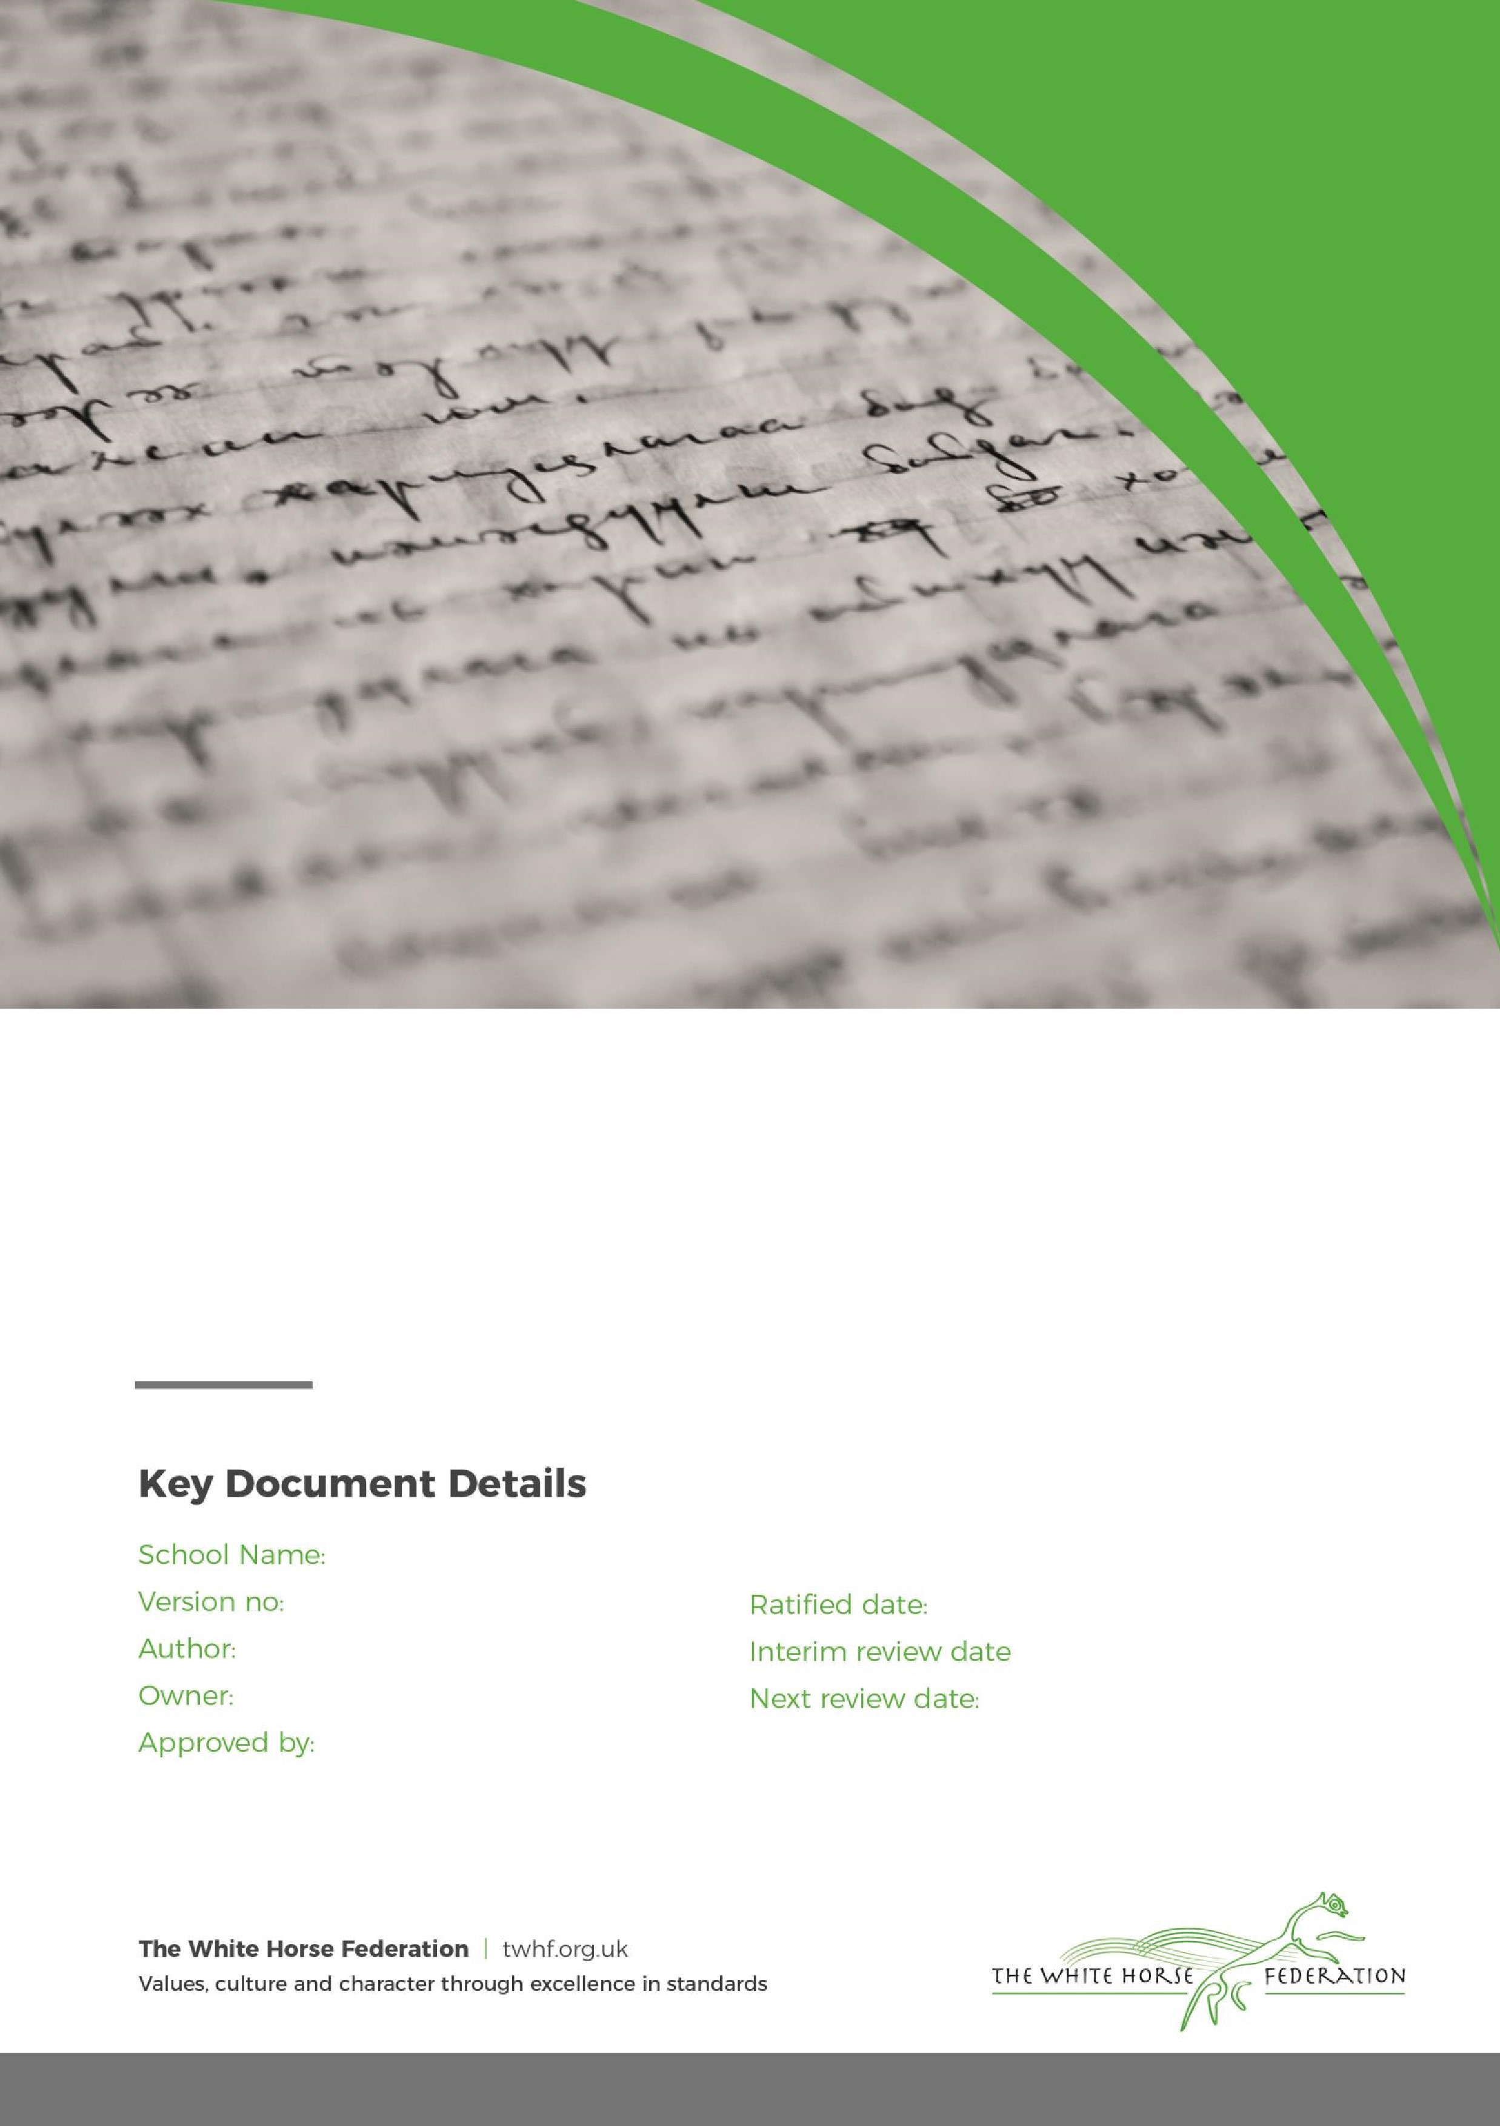

Special Education Needs (SEN)

Information Report

1

Tim James

Tim James

October 2025

September 2026

Zouch Academy

July 2026

Sarah Pearce

# **Dear Parents and Carers,**

The aim of this information report is to explain how we implement our SEND policy. In other words, we want to show you how SEND support works in our school.

If you want to know more about our arrangements for SEND, read our SEND policy.

You can find it on our website [Policies & Procedures | Zouch Academy & Nursery](https://zouch-academy.twhf.org.uk/about-us/school-information/policies-procedures)

**Note:** If there are any terms we’ve used in this information report that you’re unsure of, you can look them up in the Glossary at the end of the report.

# **1. What types of SEN does the school provide for?**

Our school provides for pupils with the following needs:

|  |  |
| --- | --- |
| **Area of need** | **Condition** |
| **Communication and interaction** | Autism spectrum disorder |
| Speech and language difficulties |
| **Cognition and learning** | Specific learning difficulties, including dyslexia, dyspraxia, dyscalculia |
|
|
| Moderate learning difficulties |
| Severe learning difficulties |
| **Social, emotional and mental health** | Attention deficit hyperactive disorder (ADHD) |
| Attention deficit disorder (ADD) |
| **Sensory and/or physical** | Hearing impairments |
| Visual impairment |
| Multi-sensory impairment |
| Physical impairment |

# **2. Which staff will support my child, and what training have they had?**

Our special educational needs co-ordinator, or SENCO

The SENCO, Miss S Pearce, is a fully qualified teacher and has gained her National Award for Special Educational Needs Co-ordinator in 2020. The Primary Inclusion Lead, Mrs J Udale has over 20 years’ experience supporting pupils with SEN in Wiltshire schools.

Class teachers

All of our teachers receive in-house SEN training, and are supported by the SENCO and Inclusion Lead to meet the needs of pupils who have SEN.

Zouch Academy and TWHF expectations are that all teachers are responsible teachers of SEN and have the support of the SENCO & Inclusion Lead to ensure good progress and attainment of all children. All teachers are committed to having a good understanding and awareness of SEND. This is achieved through ongoing CPD. Through the school year, a number of staff training sessions are spent on SEND and new practices.

Teaching assistants (TAs)

We have a team of TAs, including two higher-level teaching assistants (HLTAs), who are trained to deliver SEN provision.

Teaching Assistants are employed to support the learning needs of all the children, enabling them to access a mainstream curriculum. They are also trained to deliver interventions targeted at children’s individual plans.

Pastoral support

We also have pastoral support available to all pupils - this includes two children’s counsellors, Thrive practitioners and a qualified ELSA.

ELSA stands for Emotional Literacy Support Assistant and is a national programme of staff training to support children and young people with Social, Emotional and Mental Health (SEMH) needs. It is run by the Educational Psychology service. It supports practitioners in developing the emotional literacy and overall resiliency of vulnerable children and young people. Examples of things covered on the course are social skills, emotions, bereavement, social stories and therapeutic stories, anger management, self-esteem, counselling skills (such as solution focus) and friendship.

Staff training

All staff have access to CPD. We have a rolling programme of training and support for staff based on the needs of the pupils within school. Staff are sent on more individualised training if they are supporting a pupil with a more specific need.

Medical training to support pupils with medical care plans is organised as needed.

Many of our staff have undertaken specialist training, this includes:

|  |  |  |
| --- | --- | --- |
| **Training programme** | **When / Time** | **Who** |
| CP training and Safeguarding | Yearly updates | All Staff |
| Paediatric First Aid | 3 Year review for fully trained staff | 22 Members of staff split across both key stages |
| Thrive Practitioner Training | January 2020 with yearly updates | 2 Members of staff – 1 Teacher & Inclusion Manager |
| Implementing Thrive into Senior Management Training | October 2019 over 2 full days | Vice Principal |
| Introducing Thrive into school | October 2019 | Principal, SENCO and ELSA |
| Thrive whole school training | November 2020 | All staff |
| Five to Thrive | January 2020 | Family Support Worker |
| Team teach positive handling | Reviewed every 3 years  6 hour course | 23 members of staff includes teachers and TAs |
| NASENCO – National Award for SEN Co-Ordination | 2018-2020  Two-year course | SENCO |
| De-escalation Training | Sept 2020 | All TA’s & ECT’s |
| Insulin, epi-pen, stoma and any other relevant medical training | Annual updates | All staff directly involved with individual pupils |
| Dyslexia Friendly Schools training & Implementation | 2020 - 22 | SENCO, Inclusion Manager, all Teachers and TA’s |
| Level 2 Certificate in Understanding Autism | 2018-2022 | Three teachers and five TA’s |
| Level 2 Certificate in Understanding Behaviour that Challenges | 2020-2022 | Three teacher’s and six TA’s |
| Level 2 Certificate in Understanding Specific Learning Difficulties | 2020-2022 | One Teacher and one TA |
| Level 2 Certificate in Understanding and supporting Children & Young People’s Mental Health | 2019-2022 | Four Teachers, Inclusion manager and 7 TA’s |
| Level 3 Understanding Trauma | 2020 | FSW |
| Using Clicker to Support Literacy | Sept 2022 | Teachers, SENCO & Inclusion Lead |
| Using Widgit to support SEN | July 2022 | All staff |
| Teaching Grammar to children with language disorders | September 2019 | Two TA’s |
| Supporting children with Speech and Language difficulties | December 2019 | SENCO and One TA |
| Supporting Children and young people who self-harm | March 2020 | FSW and ELSA |
| Supporting children who have experienced Trauma | March 2020 | FSW and ELSA |
| Precision Teaching | 2025 | All TA’s |
| Understanding Youth Mental Health | 2017 | ELSA |
| Therapeutic Story Writing | 2016 | ELSA |
| Level 3 Supporting Speech and Language Difficulties in the classroom | 2017 | One TA |
| Understanding Speech & Language Targets | 2017 | All TAs |
| Emotional Literacy Support Assistant Training | 2015 | One TA (ELSA) |
| Delivering Narrative Therapy | 2018 | Two TA’s |

External agencies and experts

Sometimes we need extra help to offer our pupils the support that they need. Whenever necessary, we will work with external support services to meet the needs of our pupils with SEN and to support their families. These include:

* Educational Psychologists
* Speech and Language Therapists
* Occupational Therapist
* WAAS – Wiltshire Autism Assessment Service
* Child and adolescent mental health services CAMHS
* Wiltshire SSENS Department
* Wiltshire Behaviour Support Service
* Visual impairment advisory services
* Hearing impairment advisory services
* Assistive technology Service
* Advisory Teacher for Physical Disabilities
* Health Care professionals (School Nurse, Community pediatrician and Physiotherapists)
* CEAS- Parent Partnership
* Early Help Hub
* Social services
* Looked After Children Education Services (LACES)
* Special Educational Needs Assessment Team
* Voluntary sector organisations
* Education Welfare Officer
* Wiltshire Young Carers

# **3. What should I do if I think my child has SEN?**

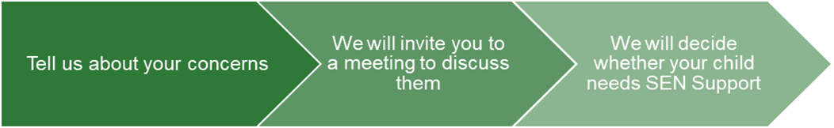

|  |  |  |
| --- | --- | --- |
| If you have any concerns, in the first instance, please discuss these with your child’s class teacher.  You can do this either at the end of the school day or through the school office on admin@zouch.wilts.sch.uk  They will pass the message on to our SENCO, Miss S Pearce, who will be in touch to discuss your concerns. | We will meet with you to discuss your concerns and try to get a better understanding of what your child’s strengths and difficulties are.  Together we will decide what outcomes to seek for your child and agree on next steps.  We will make a note of what’s been discussed and add this to your child’s record. | If we decide that your child needs SEN support, your child will be added to the school’s SEND register. A pupil profile will be made to show the individual provision and interventions your child receives, you will also receive a copy of this. |

# **4. How will the school know if my child needs SEN support?**

All our class teachers are aware of SEN and are able to identify the early signs of potential pupils who aren’t making the expected level of progress in their schoolwork or social interactions. This will include looking at their reading, writing and maths books, observations in lessons, along with observations of their social interactions.

If the teacher notices that a pupil is falling behind, they will try to find out if the pupil has any gaps in their learning through targeted assessments. If a gap is found, they will give the pupil extra tuition to try to fill it. Pupils who don’t have SEN usually make progress quickly once the gap in their learning has been filled.

If the pupil is still struggling to make the expected progress, the teacher will complete an identifications form to share with the SENCO and will contact you to discuss the possibility that your child has SEN.

Where appropriate, the SENCO will observe the pupil in the classroom and in the playground to see what their strengths and difficulties are. They will have discussions with your child’s teacher/s, to see if there have been any issues with, or changes in, their progress, attainment or behaviour.

The SENCO will ask for your opinion and speak to your child to ensure that their voice is heard also. With your consent, they may also, where appropriate, ask for the opinion of external experts such as a speech and language therapist, an educational psychologist, or a paediatrician.

Based on all of this information, the SENCO will decide whether your child needs SEN support. You will be told the outcome of the decision.

If your child does need SEN support, their name will be added to the school’s SEN register, and the SENCO will work with the class teacher to create an induvial pupil profile for them. You will receive a copy of this.

# **5. How will the school measure my child’s progress?**

We will follow the ‘graduated approach’ to meeting your child’s SEN needs.

The graduated approach is a 4-part cycle of **assess, plan, do, review**.

**Assess**

**If your child is not making the expected level of progress, we will make an assessment to find out what strengths and difficulties your child has.** **We will ask for you and your child’s input, as well as getting help from external professionals where necessary.**

**Review**

**We will assess how well the support we put in place helped the pupil to meet the outcomes we set. We will use our improved understanding of   
your child’s needs to improve the support we offer.**

**Plan**

**In discussion with you and your child, we will decide what outcomes we are hoping to achieve. We will make a plan of the support we will offer your child to help them meet those outcomes. We will make a record of this and share it with you and all relevant school staff.**

**Do**

**We will put our plan into practice.**

**The class teacher, with the support of the SENCO, will be responsible for working with your child on a daily basis, and making sure the support we put in place is having the impact we intended.**

As a part of the planning stage of the graduated approach, we will set outcomes that we want to see your child achieve.

Whenever necessary, we run an intervention with your child, we will assess them before the intervention begins. This is known as a ‘baseline assessment’. We do this so we can see how much impact the intervention has on your child’s progress.

We will track your child’s progress towards the outcomes we set over time and improve our offer as we learn what your child responds to best.

This process will be continual. If the review shows a pupil has made progress, they may no longer need the additional provision made through SEN support. For others, the cycle will continue and the school's targets, strategies and provisions will be revisited and refined.

# **6. How will I be involved in decisions made about my child’s education?**

We will provide annual reports on your child's progress.

Your child’s class teacher will meet you, at a minimum, twice a year to:

* Set clear outcomes for your child’s progress
* Review progress towards those outcomes
* Discuss the support we will put in place to help your child make that progress
* Identify what we will do, what we will ask you to do, and what we will ask your child to do

The SENCO may also attend these meetings to provide extra support.

We know that you’re the expert when it comes to your child’s needs and aspirations. We want to make sure you have a full understanding of how we’re trying to meet your child’s needs and understand that you can provide insight into what you think would work best for your child.

We also want to hear from you as much as possible so that we can build a better picture of how the SEN support we are providing is impacting your child outside of school.

If your child’s needs or aspirations change at any time, please let us know right away so we can keep our provision as relevant as possible.

After any discussion we will make a record of any outcomes, actions and support that have been agreed. This record will be shared with all relevant staff and you will be given a copy.

If you have concerns that arise between these meetings, please contact your child’s class teacher or through the school office: [admin@zouch.wilts.sch.uk](mailto:admin@zouch.wilts.sch.uk).

# 

# **7. How will my child be involved in decisions made about their education?**

The level of involvement will depend on your child’s age and level of competence. We recognise that no two children are the same, so we will decide on a case-by-case basis, with your input.

We may seek your child’s views by asking them to:

* Attend meetings to discuss their progress and outcomes
* Discuss their views with a member of staff who can act as a representative during the meeting
* Answer some questions, use picture prompts to show their answers, draw a picture to show their response or use a character or toy to communicate their answer to instead

**8. How will the school adapt its teaching for my child?**Your child’s teachers are responsible and accountable for the progress and development of all the pupils in their class.

High-quality teaching is our first step in responding to your child’s needs. We will make sure that your child has access to a broad and balanced curriculum in every year they are at our school.

We will adapt how we teach to suit the way the pupil works best. There is no 'one size fits all’ approach to adapting the curriculum, we work on a case-by case basis to make sure the adaptations we make are meaningful to your child.

These adaptations include:

* Adapting our curriculum to make sure all pupils are able to access it, for example, by grouping, 1-to-1 work, adapting the teaching style or content of the lesson, etc.
* Adapting our teaching, for example, giving longer processing times, pre-teaching of key vocabulary, reading instructions aloud, etc.
* Adapting our resources and staffing
* Using recommended aids, such as laptops, coloured overlays, visual timetables, larger font, etc.
* Teaching assistants will support pupils on a 1-to-1 or 1-to-2 basis when appropriate
* Teaching assistants will support pupils in small groups

We may also provide the following interventions and support:

|  |  |  |
| --- | --- | --- |
| **Area of need** | **Condition** | **How we support these pupils** |
| **Communication and interaction** | Autism spectrum disorder | Visual timetables  Social stories  THRIVE |
| Speech and language difficulties | Speech and language therapy |
| **Cognition and learning** | Specific learning difficulties, including dyslexia, dyspraxia and dyscalculia | Writing slope  Coloured overlays  Reading windows  Assistive technology |
|
|
| Moderate learning difficulties | Pre-teaching  Reading or Maths interventions  Lexia |
| Severe learning difficulties | Reading pens |
| **Social, emotional and mental health** | ADHD, ADD | Quiet workstation  Ear defenders  Chew toys  Fidgit toys |
| Adverse childhood experiences and/or mental health issues | Nurture groups  ELSA |
| **Sensory and/or physical** | Hearing impairment | Widgit and visual aids  Assistive technology |
| Visual impairment | Limiting classroom displays |
| Multi-sensory impairment | Extra time  Widgit pictures  Multi-sensory resources |
| Physical impairment | Adapted physical tasks  Assistive technology  Multisensory resources |

These interventions are part of our contribution to Wiltshire Council’s local offer.

# **9. How will the school evaluate whether the support in place is helping my child?**

Targets will be set and reviewed regularly to evaluate the impact of the support provided.

We will evaluate the effectiveness of provision for your child by:

* Reviewing their progress towards their goals each term
* Reviewing the impact of interventions at the end of the term
* Using pupil questionnaires
* Monitoring by the SENCO
* Using pupil profiles to measure progress
* Holding an annual review (if they have an education, health and care (EHC) plan)

# **10. How will the school resources be secured for my child?**

The school has funding for all children including children with Special Educational Needs and Disabilities. In addition, additional funding can be requested to support higher needs children or children with an Education Health and Care Plan. The Headteacher and the SENCO will discuss each child’s needs in detail and then ensure that school-based provision meets the needs of each child as detailed in the EHCP.

This may include access to:

* Additional resources
* Additional learning support
* Additional adult support
* Support from outside agencies

If more support is needed, we may consult with external agencies to get recommendations on what will best help your child access their learning.

# **11. How will the school make sure my child is included in activities alongside pupils who don’t have SEND?**

* All pupils have equal access to all facilities, activities and resources, regardless of SEND, race, religion, culture, gender, sexuality or disability determined by a thorough rigorous risk assessment procedure and adaptations will be made as needed. The Accessibility Plan details how the school aims to treat all of its pupils fairly and with respect.
* All of our extra-curricular activities and school visits are available to all of our pupils, where appropriate, including our before and after-school clubs.
* All pupils are encouraged to go on our school trips, including our residential trip such as our Year 4 residential to Grittleton House and our Year 6 residential to Pencelli.
* All pupils are encouraged to take part in celebration days, Christmas events, sports days and we will make the reasonable adjustments or adaptations that are needed to make sure that they can be included.

# **12. How does the school make sure the admissions process is fair for pupils with SEN or a disability?**

* Zouch Academy subscribes to the Wiltshire council admissions procedures and policies. Parents can apply through Wiltshire Council for Primary School admissions.
* We ensure that the learning environment is fully accessible for and inclusive for all learners. Pupils with an Education, Health and Care Plan (EHCP) at the time of allocation are required to be admitted to the school named on their plan. Once an EHCP reaches the formal proposed stage, the administration of the admission of the young person becomes the responsibility of the Special Educational Needs Assessment Team (SENAT) at which point this policy no longer applies.

# **13. How does the school support pupils with disabilities?**

* We have a disability, accessibility action plan and policy that is available on request.
* FS1 and FS2, KS1 and KS2 are fully wheelchair accessible.
* We have two disabled toilets large enough to accommodate changing and showering.
* Visual timetables are used in all classrooms.
* We ensure that the learning environment is fully accessible and inclusive for all learners.

# **14. How will the school support my child’s mental health and emotional and social development?**

We are a fully inclusive school and all staff are passionate about the well-being of each child. Our curriculum is led by our values, in which all adults adhere to. We explicitly teach pupils how to show our school values and are role models to the pupils at all times. Health, safety and well-being are also taught through lessons and assemblies. Continuous care, support and guidance in class and around school may also include:

* + - PSHE curriculum
    - Fully inclusive school where every child matters
    - Enrichment activities (Clubs and activities to broaden life experience, for example Sports and Music)
    - Medical care plans/ personal care plans
    - ELSA & Children’s Counselling
    - Some staff are trained in Mental Health First Aid
    - A number of staff are trained in First Aid who cover all areas of the school, all ages of children and the whole school day.
    - We have a ‘zero tolerance’ approach to bullying
    - Some staff are trained in positive physical intervention (Team Teach). Any physical intervention is recorded appropriately according to safeguarding and LEA guidelines and is reported to parents. Physical intervention is a last resort in order to maintain the safety of a child and others around them. It is always deemed to be reasonable and proportionate to the circumstances they were intended to prevent.
    - Buddy / Pastoral care / Thrive

# **15. What support will be available for my child as they transition between classes or settings, or in preparing for adulthood?**

We recognise that transitions can be particularly difficult for a child with SEN and take steps to ensure that any transition is as smooth as possible. As 80% of our pupils come from military families, we are very experienced in the transition of children to and from our school. We have a Family Support Worker who can discuss any concerns or issues you or your child may have regarding moving. Military families can also contact the Children’s Education Advisory Service (CEAS) particularly if you are being posted overseas [www.ceas.mod.uk](http://www.ceas.mod.uk)

Early years

* New Reception class children visit with their parents before their admission date.
* Reception and/or Nursery class teachers visit the home of every new pupil who starts in the autumn.

Between years

To help pupils with SEND be prepared for a new school year we:

* Ask both the current teacher and the next year’s teacher to attend a final meeting of the year when the pupil’s SEN is discussed
* Schedule lessons with the incoming teacher towards the end of the summer term
* Have an enhanced transition for SEN pupils with additional meet and greets and support

Between schools

If your child is moving to another school:

* We will contact the school SENCO and ensure they know about any special arrangements or support that need to be made for your child.
* We will make sure that all records about your child are passed on as soon as possible.
* When children join from another primary school, we receive transferred records and have meetings/ conference calls as needed.

Preparing for schools

* Before Year 6 pupils move on to Secondary schools, transition meetings take place between our school and secondary colleagues and pupils are invited to visit their new schools. Extra visits may be arranged for pupils with Special Educational Needs. Pupils will be prepared for the transition by:
* Practising with a secondary school timetable
* Learning how to get organised independently
* Plugging any gaps in knowledge

# **16. What support is in place for looked-after and previously looked-after children with SEN?**

Mr N Morris will work with Miss S Pearce, our SENCO, to make sure that all teachers understand how a looked-after or previously looked-after pupil’s circumstances and their SEN might interact, and what the implications are for teaching and learning.

Children who are looked-after or previously looked-after will be supported in the same way as any other child who has SEND. However, looked-after pupils will also have a personal education plan (PEP). We will make sure that the PEP and any SEN support plans or EHC plans are consistent and complement one another.

# **17. What should I do if I have a complaint about my child’s SEN support?**

Complaints about SEN provision in our school should be made to the SENCO/Headteacher in the first instance. They will then be referred to the school’s complaints policy.

[Policies & Procedures | Zouch Academy & Nursery](https://zouch-academy.twhf.org.uk/about-us/school-information/policies-procedures) 

If you are not satisfied with the school’s response, you can escalate the complaint. In some circumstances, this right also applies to the pupil themselves.

To see a full explanation of suitable avenues for complaint, see pages 246 and 247 of the [SEN Code of Practice](https://www.gov.uk/government/publications/send-code-of-practice-0-to-25).

If you feel that our school discriminated against your child because of their SEND, you have the right to make a discrimination claim to the first-tier SEND tribunal. To find out how to make such a claim, you should visit: <https://www.gov.uk/complain-about-school/disability-discrimination>

You can make a claim about alleged discrimination regarding:

* Admission
* Exclusion
* Provision of education and associated services
* Making reasonable adjustments, including the provision of auxiliary aids and services

Before going to a SEND tribunal, you can go through processes called disagreement resolution or mediation, where you try to resolve your disagreement before it reaches the tribunal.

[Mediation and appeals - Wiltshire Council](https://www.wiltshire.gov.uk/article/4289/Mediation-and-appeals)

# **18. What support is available for me and my family?**

If you have questions about SEND, or are struggling to cope, please get in touch to let us know. We want to support you, your child and your family.

To see what support is available to you locally, have a look Wiltshire Council’s at local offer. They publish information about the local offer on their website:

[SEND Local Offer - Wiltshire Council](https://www.wiltshire.gov.uk/local-offer)

Our local special educational needs and disabilities information advice and support services (SENDIASS) organisations are:

[Wiltshire](https://councilfordisabledchildren.org.uk/what-we-do-0/networks/iassn/find-your-local-ias-service/south-west/wiltshire)

National charities that offer information and support to families of children with SEND are:

* [IPSEA](https://www.ipsea.org.uk/)
* [SEND family support](https://sendfs.co.uk/)
* [NSPCC](https://www.nspcc.org.uk/keeping-children-safe/support-for-parents/)
* [Family Action](https://www.family-action.org.uk/what-we-do/children-families/send/)
* [Special Needs Jungle](https://www.specialneedsjungle.com/)

# **19. Glossary**

* **Access arrangements** – special arrangements to allow pupils with SEND to access assessments or exams
* **Annual review** –an annual meeting to review the provision in a pupil’s EHC plan
* **Area of need** – the four areas of need describe different types of needs a pupil with SEND can have. The four areas are communication and interaction; cognition and learning; physical and/or sensory; and social, emotional and mental health needs.
* **CAMHS** – child and adolescent mental health services
* **Adapt** – when teachers adapt how they teach in response to a pupil’s needs
* **EHC needs assessment** – the needs assessment is the first step on the way to securing an EHC plan. The local authority will do an assessment to decide whether a child needs an EHC plan.
* **EHC plan** –an education, health and care plan is a legally-binding document that sets out a child’s needs and the provision that will be put in place to meet their needs.
* **First-tier tribunal/SEND tribunal** – a court where you can appeal against the local authority’s decisions about EHC needs assessments or plans and against discrimination by a school or local authority due to SEND
* **Graduated approach** – an approach to providing SEN support in which the school provides support in successive cycles of assessing the pupil’s needs, planning the provision, implementing the plan, and reviewing the impact of the action on the pupil
* **Intervention** – a short-term, targeted approach to teaching a pupil with a specific outcome in mind
* **Local offer** – information provided by the local authority which explains what services and support are on offer for pupils with SEN in the local area
* **Outcome** – target for improvement for pupils with SEND. These targets don't necessarily have to be related to academic attainment
* **Reasonable adjustments** – changes that the school must make to remove or reduce any disadvantages caused by a child’s disability
* **SENCO** – the special educational needs co-ordinator
* **SEN** – special educational needs
* **SEND** – special educational needs and disabilities
* **SEND Code of Practice** – the statutory guidance that schools must follow to support children with SEND
* **SEN information report** – a report that schools must publish on their website, that explains how the school supports pupils with SEN
* **SEN support** – special educational provision which meets the needs of pupils with SEN
* **Transition** – when a pupil moves between years, phases, schools or institutions or life stages