Curriculum Intent
Writing at
Zouch

At Zouch, we intend for all children to be immersed in a range of themes, authors and genres to help support them to discover and form their own authorial voice. Our writing curriculum aims to empower all children to acquire the vocabulary, skills, knowledge and understanding necessary for confident and effective written communication both now and in the future.

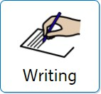
The effective teaching of writing runs through every aspect of our curriculum to achieve high quality outcomes for pupils.
Writing makes up part of our outer curriculum and reflects our embedded values including understanding, responsibility and independence.

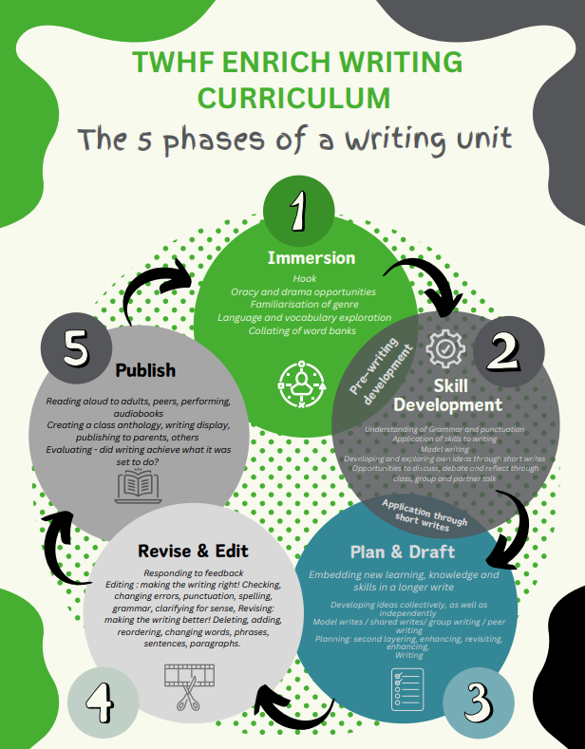
Curriculum Impact
By the end of KS2, we aim that our pupils have developed an understanding of the importance writing has in all aspects of life. The children will be able to express themselves through spoken and written word and write effectively for a range of purposes.
Towards the end of their primary school learning journey, children will be able to effectively select appropriate features for a range of genres and will be able to adapt and manipulate these features to create their own, successful pieces of writing for a range of purposes and audiences.

Assessment

Teachers will use formative assessment during lessons to assess children’s understanding of the skills which have been taught. The children’s writing will be moderated throughout the year to form an accurate teacher judgement on their attainment.
Our values
Our values

Curriculum Implementation
Writing lessons at Zouch follow the Whitehorse ENRich curriculum and are carefully planned and sequenced in units to build on prior learning. We believe that for children to succeed, lessons must be exciting and engaging for all genders, purposeful and closely linked to a range of high-quality texts and/or current learning themes. Our writing curriculum is broad and balanced to cover a range of skills such as spelling, handwriting, grammar, aspirational vocabulary, syntax, composition and creativity; these skills are then applied in a wide range of other subjects. Objectives are ambitious for all, to enable children to reach the highest standards, and these objectives are adapted to meet the needs of children with SEND and those who are disadvantaged. In EYFS the children are given the opportunity to practise their mark making skills which develops into simple writing. These irresistible opportunities are found within the indoor and outdoor learning environments.

