Music development plan summary:
Zouch Academy

Overview
Detail | Information
Academic year that this summary covers | 2025-2026
Date this summary was published | 01.09.25
Date this summary will be reviewed | 01.09.26
Name of the school music lead | Rebecca Kinderman
Name of school leadership team member with responsibility for music (if different) | Nina Johnson
Name of local music hub | GSW Music Hub
Name of other music education organisation(s) (if partnership in place)

This is a summary of how our school delivers music education to all our pupils across three areas – curriculum music, co-curricular provision and musical experiences – and what changes we are planning in future years. This information is to help pupils and parents or carers understand what our school offers and who we work with to support our pupils’ music education.

Part A: Curriculum music
This is about what we teach in lesson time, how much time is spent teaching music and any music qualifications or awards that pupils can achieve.
“Music gives a soul to the universe, wings to the mind, flight to the imagination and life to everything.” Plato
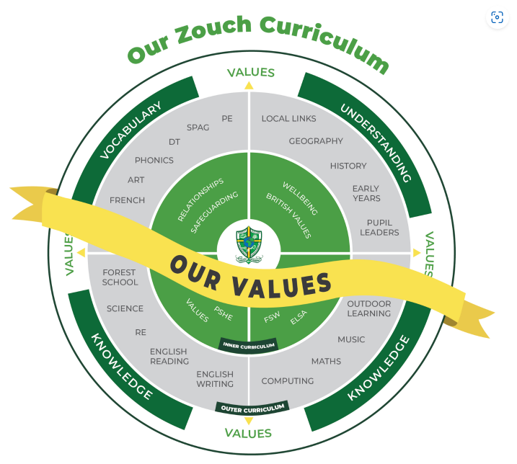
An overview of music teaching at Zouch
Music makes up part of our outer curriculum and reflects our embedded values including appreciation and thoughtfulness. We value music because it is a powerful and unique form of communication that can change and impact the way children feel, think and act.

At Zouch Academy our music curriculum is broken down into the four inter-related dimensions for music: performing, composing, listening and the history of music. These areas have been sequenced in each year group, ensuring they are progressive and everyone understands the intended end-points.

At Zouch we aspire to deliver a rich purposeful and engaging music curriculum to all children. Our aim is that children gain a firm understanding of what music is through listening, singing, playing, evaluating, analysing and composing across a wide variety of historical periods, styles, traditions and musical genres.

Our music lessons and extra-curricular musical opportunities, such as Young Voices, access to peripatetic teachers, aim to engage and inspire pupils to develop a love of music and harness their musical talent as musicians and in doing so, increasing self-confidence, creativity and sense of achievement.

Pupils celebrate the love of music through a richness of school experiences - singing in assemblies, carefully chosen music to accompany assemblies, year group performances and in the Early years, a progressive approach to the joy of singing and learning nursery rhymes and songs.

In Reception and Key Stage One, the Kapow scheme of learning is followed and, where possible, music themes are linked to the history and geography theme for the term to deepen our children’s understanding. In Lower Key Stage Two, children receive three terms of recorder tuition and follow Kapow for the remaining three. In Upper Key Stage Two, our children receive three terms of brass instruments tuition and follow Kapow for the three remaining terms.

Principles of Learning
Like other foundation subjects, Music lessons have a clear process which involves recapping learning, exploring music as a subject, presenting a clear objective and key vocabulary as well as summarising the knowledge, skills and understanding the children will learn. It is important for children to be able to think both consciously and unconsciously (thought processes, memory, affect, motivation) about music.

Learning is a change in long-term memory - the most important enabler of development; changes to long-term memory occur through learning tacit, procedural or declarative knowledge. These form the curriculum content and knowledge base we need to consider when implementing our music curriculum:
- Tacit knowledge is knowledge gained through experience.
- Procedural knowledge is what is exercised in the performance of a task
- Declarative knowledge refers to facts and information e.g. styles, composers.
It is our intent that our pupils will develop mastery across the curriculum as a result of our carefully sequenced curriculum which builds progressively on knowledge and skills.

Rich language
Our intent is for all pupils to acquire knowledge, develop their vocabulary and have the tools to communicate their ideas and learning effectively, both in writing and orally. Our curriculum is planned to include high quality texts and real-life experiences that creates opportunities for pupils to engage in and be immersed in the rich language of the arts.

Curriculum Intent
At Zouch, we intend for all children to feel that they are musical and to develop a life-long love of music. We focus on developing the skills, knowledge and understanding that children need in order to became confident performers, composers and listeners. Our curriculum introduces children to music from all around the world and across generations, teaching children to respect and appreciate the music of all traditions and communities. We follow Kapow Primary Music scheme of work and have an external music teacher for years 4 and 6 which enables pupils to meet the end of key stage attainment targets outlined in the national curriculum.

Curriculum Implementation
The Kapow music scheme takes a holistic approach to music in which the individual strands below are woven together to create engaging and enriching learning experiences:
• Performing
• Listening
• Composing
• The history of music

The inter-related dimensions of music
Each five-lesson unit combines these strands within a cross-curricular themed design to capture pupils’ imagination and to encourage them to explore music enthusiastically. Over the course of the scheme, children will be taught to play tuned and untuned instruments accurately and with control. They will learn to recognise and name the interrelated dimensions of music – pitch, duration, tempo, timbre, structure, texture and dynamics – and use these expressively in their own improvisations and compositions. Our instrumental lessons taught by an external music teacher complement the Kapow scheme of work and allow key stage 2 pupils to develop expertise in learning a tuned instrument for a whole year.

Curriculum Impact
After the implementation of our music teaching pupils will leave our school equipped with a range of kills to enable them to succeed in their secondary education and to be able to enjoy and appreciate music throughout their lives.
Children will:
• Be confident performers, composers and listeners and will be able to express themselves musically at and beyond school.
• Show an appreciation and respect for a wide range of musical styles from around the world and will understand how music is influenced by the wider cultural, social and historical contexts in which it is developed.
• Understand the ways in which music can be written down to support performing and composing activities
• Demonstrate and articulate an enthusiasm for music and be able to identify their own personal musical preferences.

SEND Education
There are some general principles which are particularly important for SEND learners.
Namely, these are:
- cognitive load theory,
- explicit teaching of curriculum ‘components’
- clarity of instruction.

There is no one-size-fits-all approach; however, when barriers are identified and overcome, potential can be achieved. High expectations for all pupils are therefore so important. Research suggests the following strategies are important to consider for SEND learners and these form the basis for Zouch lessons:
- breaking down tasks
- reducing the burden on working memory
- using appropriately supportive routines
- using a combination of learning modes which enhance clarity or accessibility
- the adaption of materials to ensure good challenge which is achievable.

Assessment
Music is monitored through formative assessment opportunities. Summative assessment is monitored by the subject lead and takes the form of recordings and other creative tools so that assessment processes does not detriment delivering the curriculum. Low stakes quizzes are built into lessons to ensure it is a useful learning activity which supports pupils in retaining knowledge in long-term memory.

Feedback
Diagnostic feedback is one of the most significant learning opportunities a teacher can offer. Formative assessment is far more important in music than summative judgements. Feedback which responds to errors is a frequent form of feedback in music, and should be addressed at the component level. It is highly likely that children will benefit more from teacher feedback in music education due to the need for novices to receive feedback from someone which much greater expertise.

Pupil Attention and Motivation for music education
Pupils need good feedback when they are learning new material as they are often unable to provide self-feedback at this stage. The following principles of Zouch teaching enables the best outcomes for all pupils:
- Keeping the surface structure of tasks simple and consistent provides more space for pupils to think about the crucial details.
- Peaceful, calm classrooms are conducive to pupil learning.
- Attention is influenced by peers: promoting group attention can encourage waverers to pay more attention.
- Motivation affects attention and effort.
- Good outcomes enhance intrinsic motivation.
- Tasks which provide well-judged challenge have a positive impact on motivation and attention.

Part B: Co-curricular music
This is about opportunities for pupils to sing and play music, outside of lesson time, including choirs, ensembles and bands, and how pupils can make progress in music beyond the core curriculum.
Zouch works in partnership with Wiltshire Music Connect. We will continue to explore new musical providers in 25-26 to offer further wider musical opportunities for KS1 & KS2 pupils.

Below is a list of several of the ways we develop co-curricular music at Zouch:

- Assembly time is set aside to include singing opportunities throughout the year.
- Children are introduced to new songs and enjoy time to practice, rehearse and perform together.
- Peripatetic lessons will also be available for 25-26 to enable parents to sign up to additional tuition.
- Clubs are offered throughout the year with a musical focus to further celebrate the love of music.
- Singing in lessons (outside of music lessons) to learn facts, times tables etc.
- All local music events shared with families in the newsletter & website.
- Weekly recognition from the headteacher for musical achievements outside of school.
- Peripatetic lessons (including instrument loan and entry for grades, where appropriate). Provision for pupils to practise their instrument at playtimes and lunchtimes.
- Optional playtime/lunchtime ukulele lessons throughout the year.
- Christmas Carols in the autumn term (lunchtimes).
- Creating media Audio production – exploring music digitally - compose on iPads during wet playtimes and lunchtimes.
- Wide range of repertoire of music played as children enter assemblies.
- Forest school – music & sound-making in the natural environment.
- Musical opportunities linked to termly ‘new’ language focus

Part C: Musical experiences
This is about all the other musical events and opportunities that we organise, such as singing in assembly, concerts and shows, and trips to professional concerts.
- Assembly time for singing
- Class time for singing
- Performances for key school events (Remembrance, Christmas, Harvest etc)
- Community events
- Peripatetic music lessons
- Opportunities to perform in celebration assemblies
- Theatre trips
- Competitions (Young Voices)
- Lunchtime music opportunities to celebrate personal musical achievements

In the future
This is about what the school is planning for subsequent years.
At Zouch, the senior leadership team and music lead will continue to seek opportunities and experiences that will enhance the love of music for pupils. We will ensure:

- All pupils know that they can perform in assembly.
- Invite music groups into school to perform more regularly.
- Work with the wider Trust team to create a music celebration platform across TWHF.
- Seek opportunities with feeder secondary schools for KS3 & 4 to perform to primary.
- Seek theatre trips for pupils to experience music within performances and storylines.
- Invite musicians to play for the children at key points throughout the academic year.
- Use our military links to celebrate music within the Armed Forces.
- Share music teaching with parents and stakeholders so all parties are informed of our Zouch approach, achievements and aspirations.
- Ensure pupils have access to wider opportunities e.g Young Voices.

Further information (optional)
GSW Music Hub
gswmusichubswindwilts.org.uk

Farringdon Road
Swindon
Wiltshire
SN1 5BJ
Wider reading
A Summary of Ofsted's Music Research Review for Teachers and Leaders (marcrhayes.com)
National Curriculum - Music key stages 1 to 2 (publishing.service.gov.uk)
Striking the right note: the music subject report - GOV.UK (www.gov.uk)

